**MASTER SLAVE SETUP**

1. Access Jenkins Console https: // serverip:8080
2. Under Jenkins Dashboard click on **“Manage Jenkins”** and in the next screen click on **“Manage Nodes”**

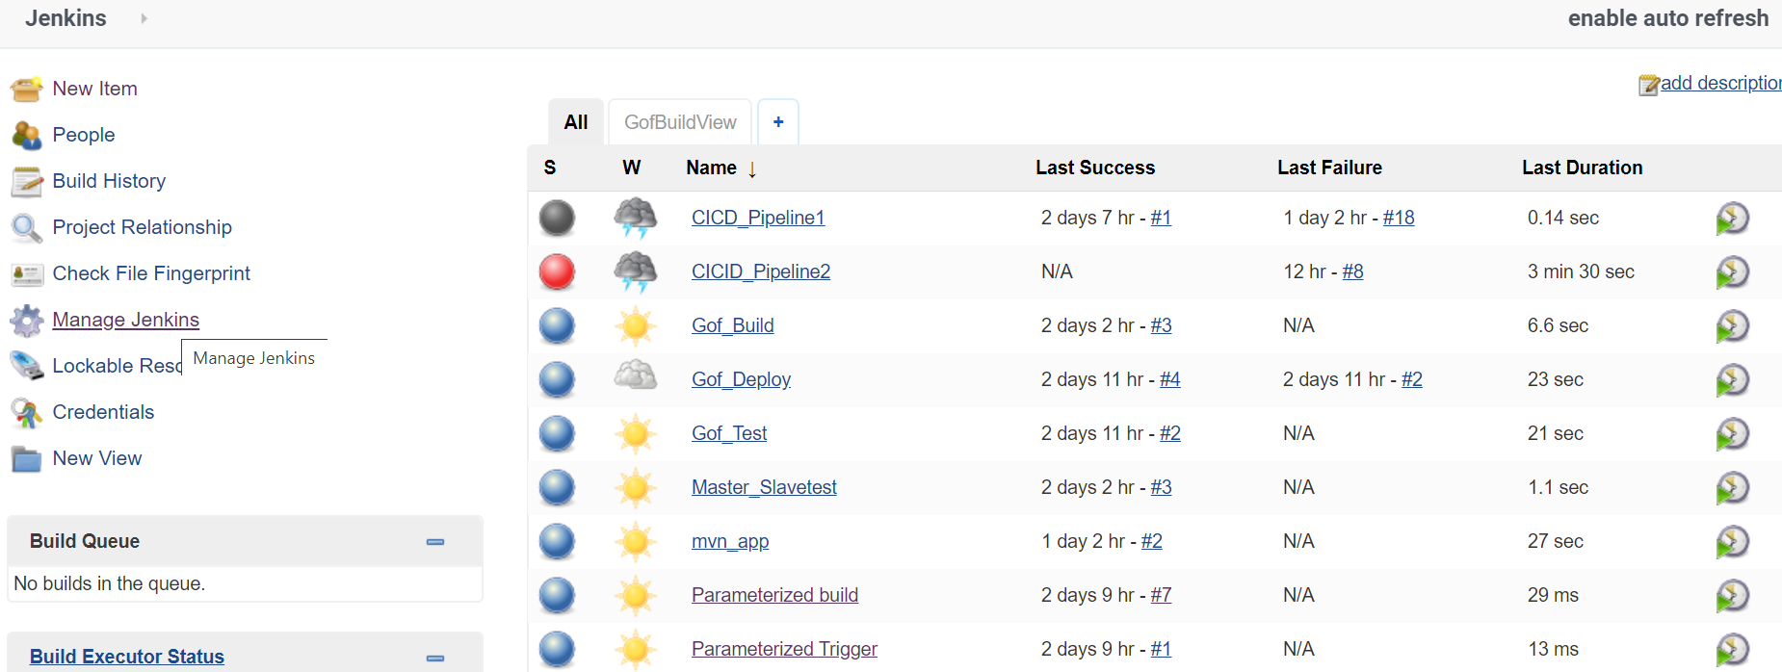

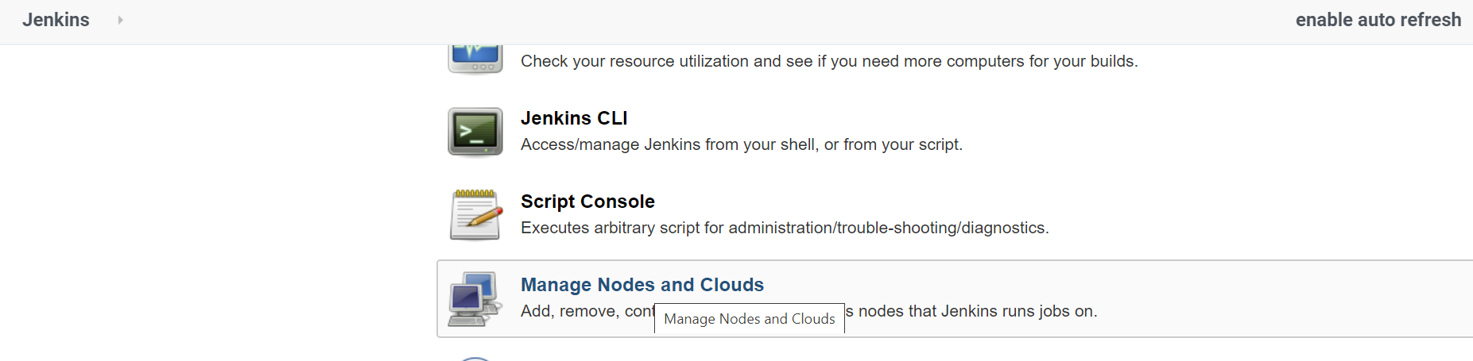

3.Give the Node Name, Select Permanent Agent and perform the below steps as given in the screenshot. Once done , Click Save.

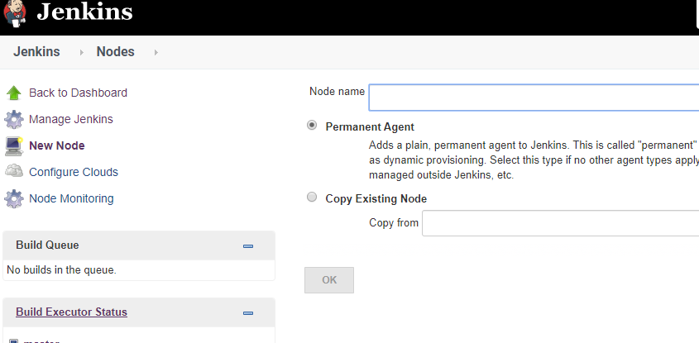

**Fill the below details**

Remote Directory : Path on the Slave node where the job executes

Labels: It’s a grouping of Nodes (Ex: UAT nodes, PROD nodes, Training etc)

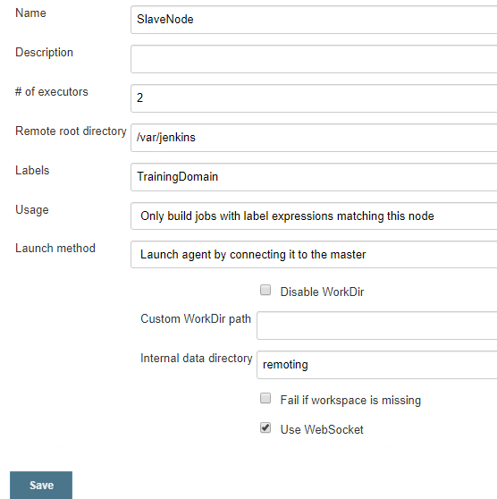

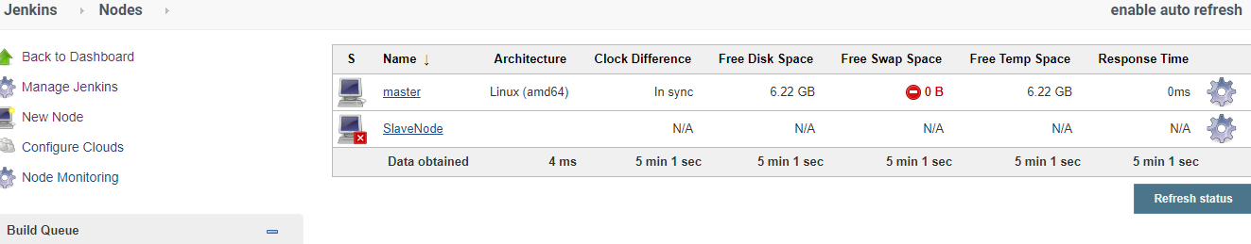

4.Click on the SlaveNode and download the agent.jar on your system as shown below and copy into the slave node under Jenkins

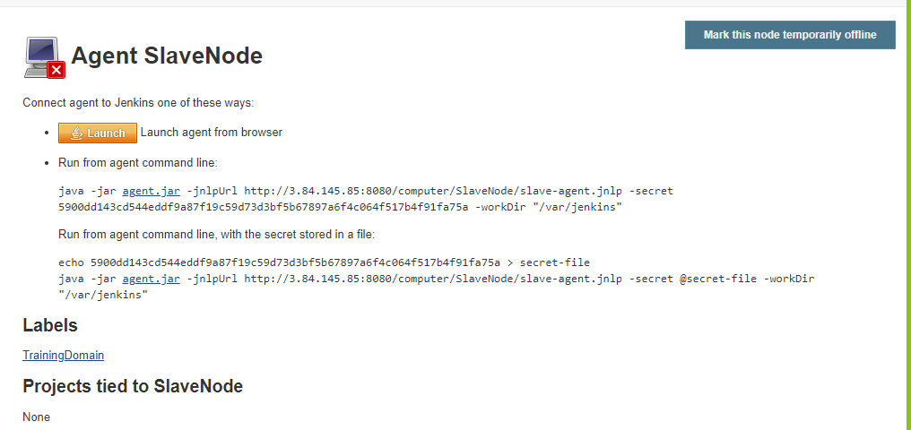

5. Use wget command to download the file under Jenkins directory

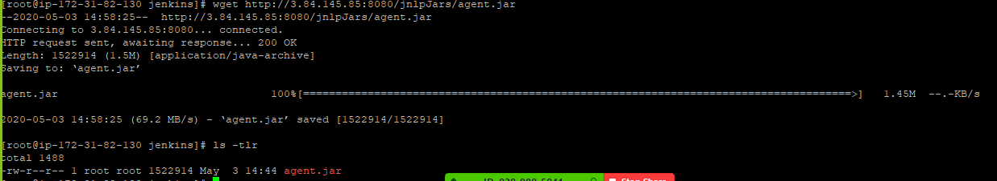

1. Execute below command to establish connection between master and slave node.

java -jar [agent.jar](http://3.84.145.85:8080/jnlpJars/agent.jar) -jnlpUrl http://3.84.145.85:8080/computer/SlaveNode/slave-agent.jnlp -workDir "/var/jenkins"

7. Now you can see Slave Node is online on the Jenkins Console

8. Let us now execute Sample Job on Slave Node as given below

1. Under Jenkins Dashboard, Click on New Item
2. Name the project as Master_Slave Setup and choose Pipeline as the project type
3. Add below script in Pipeline Tab

pipeline {

agent {label 'TrainingDomain'}

stages {

stage('Hello') {

steps {

sh 'touch hello.txt'

}

}

}

}

1. Click on Apply and Build the Job
2. You can see the below output which says its executed on Slave Node

Started by user unknown or anonymous

Running in Durability level: MAX_SURVIVABILITY

[Pipeline] Start of Pipeline

[Pipeline] node

Running on [SlaveNode](http://3.84.145.85:8080/computer/SlaveNode/) in /var/jenkins/workspace/Master_Slavetest

[Pipeline] {

[Pipeline] stage

[Pipeline] { (Hello)

[Pipeline] sh

+ touch hello.txt

[Pipeline] }

[Pipeline] // stage

[Pipeline] }

[Pipeline] // node

[Pipeline] End of Pipeline

Finished: SUCCESS